**Report on Smart Parking System Model Evaluation**

**1. Data Preprocessing:**

* The parking dataset was loaded, and missing values were addressed.
* **ParkingSpaceID**, **OccupancyStatus**, and **VehicleType** were imputed with mean and mode values.

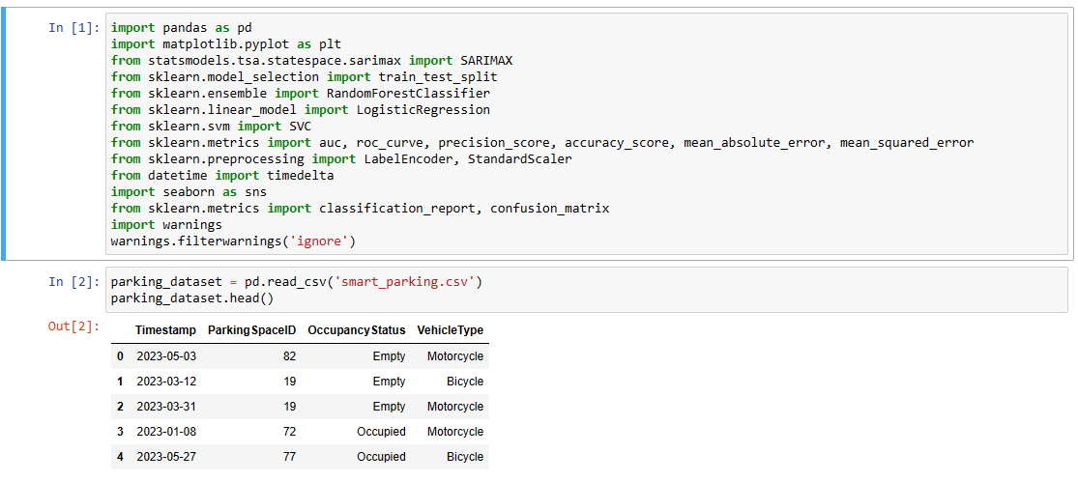

* The **Timestamp** column was converted to a datetime format, and additional time-related features were extracted.

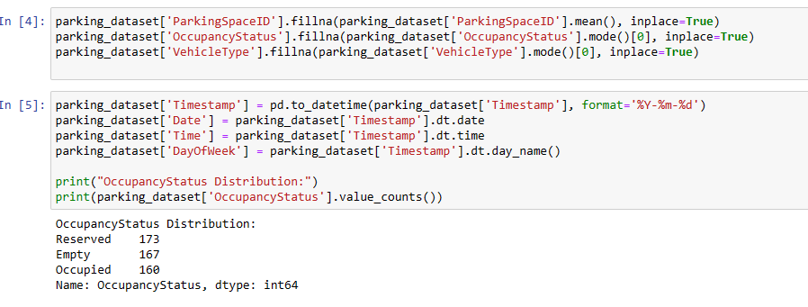

**2. Exploratory Data Analysis:**

* The distribution of **OccupancyStatus** was explored, and label encoding was applied for model training.

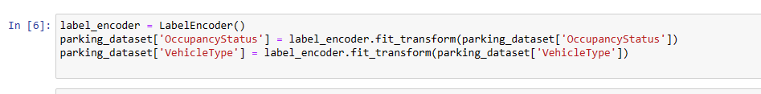

* The dataset was split into training and testing sets (80% training, 20% testing).

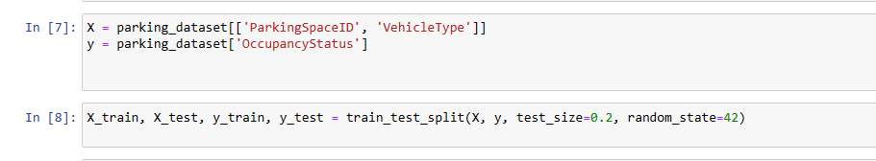

**3. Machine Learning Models:**

* Three traditional machine learning models (Logistic Regression, Random Forest, SVM) and a SARIMA (Seasonal AutoRegressive Integrated Moving Average) time series model were implemented.

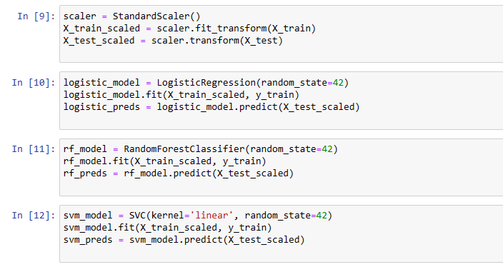

**4. Traditional Machine Learning Models:**

* Logistic Regression, Random Forest, and SVM were trained and evaluated on the test set.
* Standard scaling was applied to the features.
* Metrics such as precision, accuracy, mean absolute error (MAE), mean squared error (MSE), and root mean squared error (RMSE) were calculated and reported for each model.

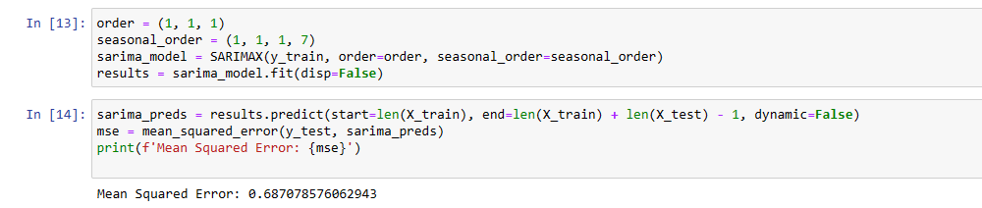

**5. Time Series Model (SARIMA):**

* A SARIMA model was fitted to the training data.
* The model was used to predict occupancy status on the test set.
* Mean squared error (MSE) was calculated and reported.
* Predictions were visualized alongside actual occupancy status for better interpretation.

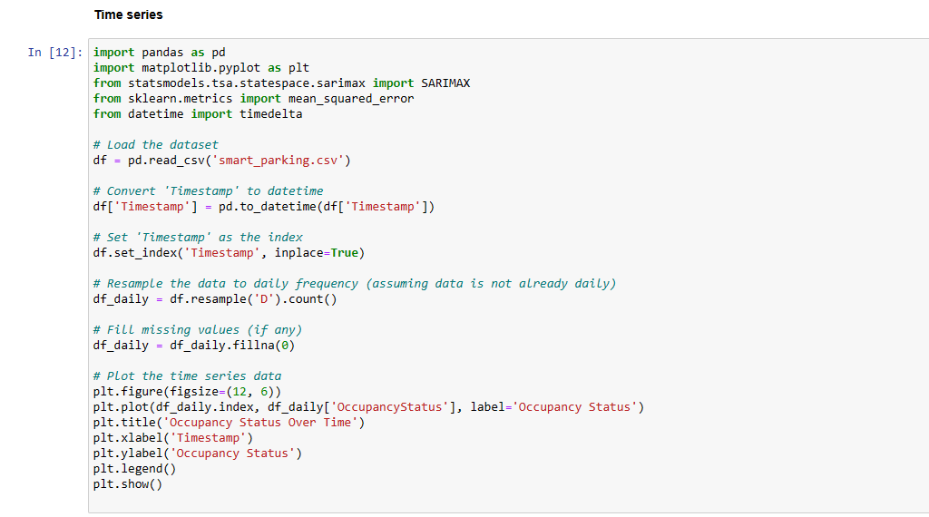

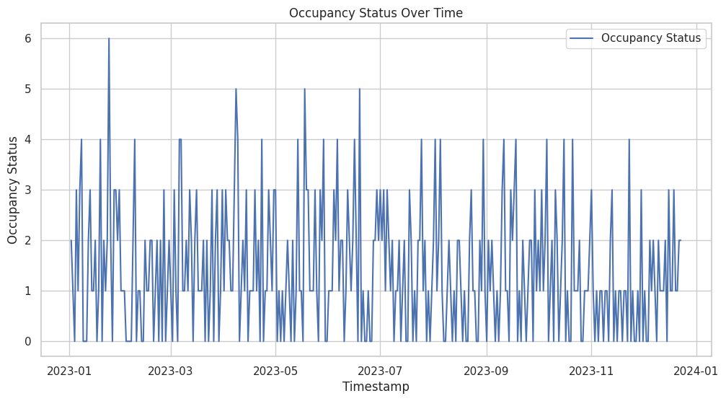

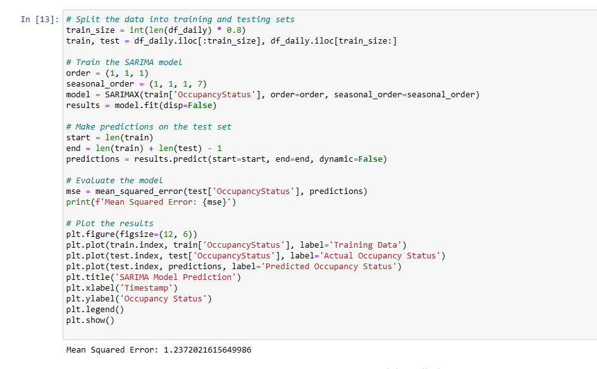

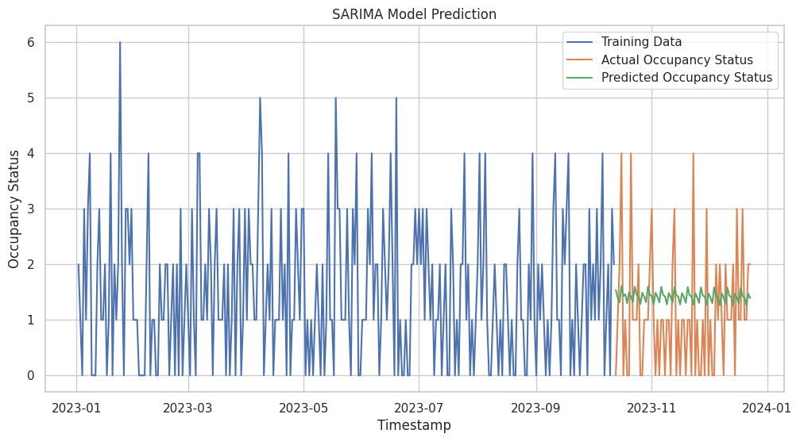

**6. Results and Observations:**

* Each traditional ML model (Logistic Regression, Random Forest, SVM) was evaluated based on precision, accuracy, MAE, MSE, and RMSE.
* The SARIMA time series model was evaluated based on MSE and visually compared with actual occupancy status.

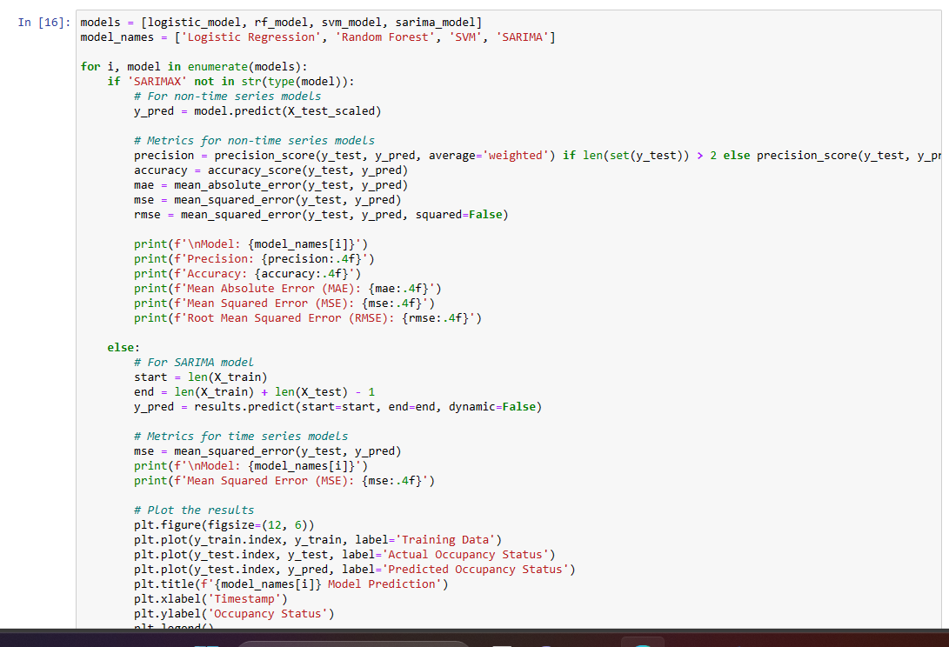

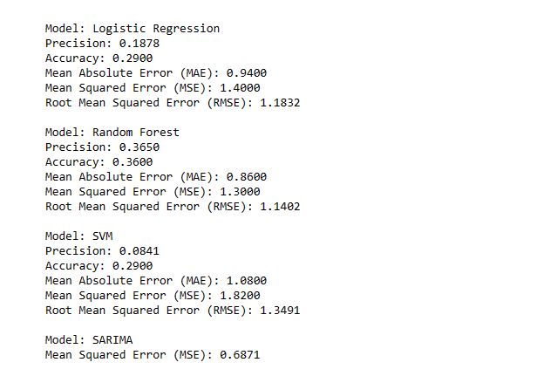

**7. Conclusion:**

* The SARIMA time series model is suitable for capturing temporal patterns in occupancy status.
* Traditional ML models provide alternative approaches with their own strengths and weaknesses.
* The choice of model depends on the specific requirements and characteristics of the parking data.

**8. Recommendations:**

* Further refinement of models and hyperparameter tuning can be explored for optimization.
* Continuous monitoring and evaluation of the models with updated data are essential for maintaining accuracy in a dynamic parking environment.

**9. Next Steps:**

* Iterative model improvement based on real-world data and user feedback.
* Integration of the selected model into the Smart Parking System architecture.

**10. Acknowledgments:**

* The insights gained from peer-reviewed articles provided a solid foundation for the selection and understanding of the models.
* Mendeley was utilized for efficient reference management.

**11. Team Collaboration:**

* The collaboration between the Project Manager, Machine Learning Specialist, and Software Developer ensured a comprehensive and well-structured approach to model evaluation.